**20K PHAROAH’S PROSPERITY**

**MEMBERSHIP DRIVE**

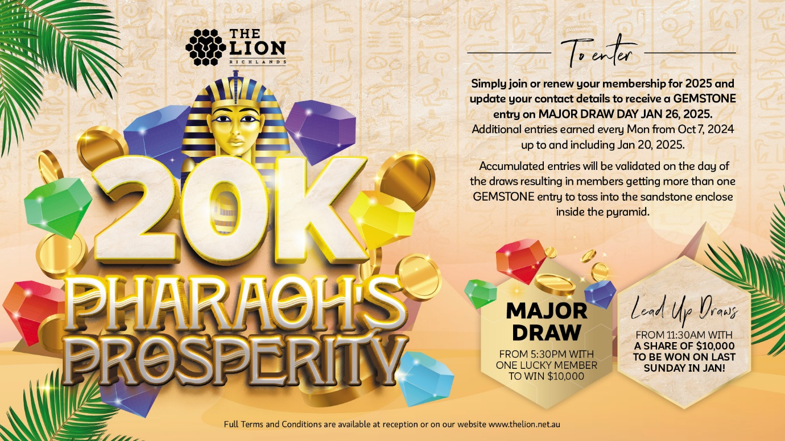

Membership Promotion runs from 01/10/24 to 26/01/25.

**TERMS & CONDITIONS OF ENTRY**

The promoter is the Queensland Lions Football Club (THE LION Richlands)*.* By entering the “20K PHAROAH’S PROSPERITY” promotion, you are agreeing to the following terms and conditions. Entry details remain the property of THE LION Richlands. By entering the promotion, winners agree to have their photo taken for promotional purposes.

**MECHANICS**

To claim a prize in the “20K PHAROAH’S PROSPERITY” promotion, the drawn member for each component MUST be a 2025 financial member of the club and opted in to receive both SMS and email marketing communications and be present at the time of the draws.

Members who have renewed their membership for 2025 will earn 1 entry on the **MAJOR DRAW** Day Jan 26, 2025, in the form of a custom numbered Gemstone by showing their 2025 membership card to promotional staff.

Additional entries will be earned for ten ***2025 financial members*** selected randomly in Gaming, Restaurant Bar, Restaurant, Café & Sports Bar each week between Oct 7, 2024 up to and including Jan 20, 2025. All members with additional entries will be contacted each week to inform them of how many entries they’re entitled to on the **MAJOR DRAW** Day. All accumulated entries will be validated on the **MAJOR DRAW** Day (i.e., members will be given more than 1 numbered Gemstone). The winning members will be required to display their 2025 membership card for THE LION Richlands upon request by the promotion staff.

Once a member has received their Gemstone (Gemstones are numbered and will need to be recorded on a Runsheet next to a members membership number), they are then to toss the Gemstone into the sandstone enclosure located inside the Pyramid in the foyer.

There will be a total of 24 cash prizes to be won on **MAJOR DRAW** Day (Jan 26th, 2025). The draws will start at 11:30am and run through to 5:15pm with one member drawn every 15 minutes by a promotional staff member who will use the sandstone enclosure to draw out a Gemstone.

The promotional staff is to then match the numbered Gemstone to a members membership number and call out their name over the microphone. The winning member is to then draw out a Gemstone trophy from the Pharoah’s & Queen’s headdress that will have an engraved cash amount they’ve won.

Prior to announcing the winning member of each these draws, the eligibility criteria will be checked in the Talkbox system. Members have 3 minutes to present themselves to the promotional staff or a redraw will occur.

The finalist for the **MAJOR DRAW** will be drawn at 5.30PM on Jan 26, 2025. The promotional staff is to then match the numbered Gemstone to a members membership number and call out their name over the microphone. Prior to announcing the winning member, the eligibility criteria will be checked in the Talkbox system. The winner will have 3 minutes to present themselves to the promotional staff or a redraw will occur. The winner will be presented with a guaranteed prize of $10,000 as well as complimentary champagne.

There are two individual components to this promotion as defined below:

**1/ Lead up draws on major draw day**

There will be a total of 24 cash prizes to be won on **MAJOR DRAW** Day (Jan 26th, 2025). The draws will start at 11:30am and run through to 5:30pm with one member drawn every 15 minutes by a promotional staff member who will use the sandstone enclosure to draw out a Gemstone.

The promotional staff is to then match the numbered Gemstone to a members membership number and call out their name over the microphone. The winning member is to then draw out a Gemstone trophy from the Pharoah’s & Queen’s headdress that will have an engraved cash amount they’ve won.

All members who win in the lead up draws will have their Gemstones entries placed back into the sandstone enclosure for a second chance at the **MAJOR DRAW** (5.30PM).

There will be a total of 24 draws in total, prize breakdown as follows - 4x $1000 | 4x $500 | 4x $400 |4x $300 | 4x $200 | 4X $100 making the total amount guaranteed to be given away in this component $10,000.

**3/ Major Draw**

The finalist for the **MAJOR DRAW** will be drawn at 5.30PM on Jan 26, 2025. The promotional staff is to match the numbered Gemstone to a members membership number and call out their name over the microphone. Prior to announcing the winning member, the eligibility criteria will be checked in the Talkbox system. The winner will have 3 minutes to present themselves to the promotional staff or a redraw will occur. The winner will be presented with a guaranteed prize of $10,000 as well as complimentary champagne.

**LIABILITY TERMS OF PROMOTION**

THE LION Richlands is not liable for any loss, damage, or injury by any person in connection with the Major Promotion.

The **MAJOR DRAW** Day is subject to change, pending COVID closures or further restrictions are announced. THE LION Richlands reserves the right to change the process for the final draw should restrictions change. These changes will be announced via SMS and/or email to all members prior to the final draw.

Board of Directors, management, staff, and immediate family0 members of the aforementioned are ineligible to claim a prize.

The decisions of the management of THE LION Richlands are final. No correspondence or third-party actions will be entered into. If a member is found to be abusing this promotion a decision will be made by management to refuse entries. This includes all requests to replace misplaced, lost, or stolen Gemstones.

Promotional materials are void if stolen, forged, mutilated, or tampered with in any way. No responsibility is accepted for late, lost or misdirected entries. Management reserves the right to amend any terms and conditions listed throughout the promotional period.

In the case of the intervention of any outside act, that hinders the Promoter’s ability to proceed with the promotion on the dates and in the manner described in these terms and conditions, including but not limited to vandalism, power failures, natural disasters, etc., the Promoter may in its absolute discretion take any action that may be available, including to cancel, terminate, modify or suspend the promotion.